Chapter 3 Assignments

1. Suppose a process in Host C has a UDP socket with port number 6789. Suppose both Host A and Host B each send a UDP segment to Host C with destination port number 6789. Will both of these segments be directed to the same socket at Host C? If so, how will the process at Host C know that these two segments originated from two different hosts?
Answer:
Yes, both segments will be directed to the same socket. For each received segment, at the socket interface, the operating system will provide the process with the source IP addresses to determine the origins of the individual segments.

2. Suppose Client A initiates a Telnet session with Server S. At about the same time, Client B also initiates a Telnet session with Server S. Provide possible source and destination port numbers for
a. The segments sent from A to S.
b. The segments sent from B to S.
c. The segments sent from S to A.
d. The segments sent from S to B.
e. If A and B are different hosts, is it possible that the source port number in the segments from A to S is the same as that from B to S?
f. How about if they are the same host?

Answer:

 | source port  numbers | destination port  numbers
a) A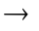S | 4467* | 23
b) BS | 5513* | 23
c) SA | 23 | 4467*
d) SB | 23 | 5513*
* Note here A and B can have any possible port numbers larger than 1024.
e) Yes.
f) No, it’s impossible that A and B have the same port number.

3. Describe why an application developer might choose to run an application over UDP rather than TCP.

Answer:
UDP has better control over what and when is sent in a segment. The reasons that some applications choose to run over UDP includes but not limited to:
- no connection establishment (which can add delay)
- no retransmission (which can add delay)
- simple: no connection state at sender, receiver
- small segment header: 8 bytes
- no flow control and congestion control: UDP can blast away as fast as desired

4. Consider the 5-bit generator, G= 10011, and suppose that sender has the value 1010101010. What is the value of CRC
Answer:
If we divide 10011 into 10101010100000, we get a remainder of R=0100. Note that, G=10011 is CRC-4-ITU standard.
So the CRC = 0100.

5. Considering the TCP 32-bit sequence number. How long will the sequence number will be used up when (Note: For TCP, each byte has a unique sequence number.)
- The line is 56-kbps
- The line is 10-Mbps
- The line 1 Gbps.
- Suppose a packet can stay in Internet for 1 minute at most. Do you think 32-bit sequence number is enough for 1Gbps network? If not enough, how TCP deal with this problem?

Answer:
The 32-bit sequence number can have up to 2^32 sequence numbers. So in TCP case, the whole sequence number space can send up to 2^32 bytes before wrapping around.
- If the line is 56-kbps, the time to transmit the 2^32 bytes is: 2^32*8/56k = 170 hours
- If the line is 10-Mbps, the time to transmit the 2^32 bytes is: 2^32*8/10M =57 minutes
- If the line is 1-Gbps, the time to transmit the 2^32 bytes is: 2^32*8/1G = 34 senconds
- Suppose a packet can stay in Internet for 1 minute at most, 32-bit sequence number is not enough for 1Gbps network, i.e., there might be two different TCP segment with same sequence number. To deal with this problem, TCP introduces a TIMESTAMP field in TCP option. Sequence number and Timestamp together uniquely identify a segment.

6. We have said that an application may choose UDP for a transport protocol because UDP offers finer application control (than TCP) of what data is sent in a segment and when.
a. Why does an application have more control of what data is sent in a segment?
b. Why does an application have more control on when the segment is sent?
Answer:
a) Consider sending an application message over a transport protocol. With TCP, the application writes data to the connection send buffer and TCP will grab bytes without necessarily putting a single message in the TCP segment; TCP may put more or less than a singe message in a segment. UDP, on the other hand, encapsulates in a segment whatever the application gives it; so that, if the application gives UDP an application message, this message will be the payload of the UDP segment. Thus, with UDP, an application has more control of what data is sent in a segment.

b) With TCP, due to flow control and congestion control, there may be significant delay from the time when an application writes data to its send buffer until when the data is given to the network layer. UDP does not have delays due to flow control and congestion control.

7. Compare GBN, SR, and TCP (no delayed ACK). Assume that the timeout values for all three protocols are sufficiently long such that 5 consecutive data segments and their corresponding ACKs can be received (if not lost in the channel) by the receiving host (Host B) and the sending host (Host A) respectively. Suppose Host A sends 5 data segments to Host B, and the 2nd segment (sent from A) is lost. In the end, all 5 data segments have been correctly received by Host B.
a. How many segments has Host A sent in total and how many ACKs has Host B sent in total? What are their sequence numbers? Answer this question for all three protocols.
b. If the timeout values for all three protocol are much longer than 5 RTT, then which protocol success fully delivers all five data segments in shortest time interval?
Answer:
a).
GoBackN:
A sends 9 segments in total. They are initially sent segments 1, 2, 3, 4, 5 and later re-sent segments 2, 3, 4, and 5.
B sends 8 ACKs. They are 4 ACKS with sequence number 1, and 4 ACKS with sequence numbers 2, 3, 4, and 5.

Selective Repeat:
A sends 6 segments in total. They are initially sent segments 1, 2, 3, 4, 5 and later re-sent segments 2.
B sends 5 ACKs. They are 4 ACKS with sequence number 1, 3, 4, 5. And there is one ACK with sequence number 2.

TCP:
A sends 6 segments in total. They are initially sent segments 1, 2, 3, 4, 5 and later re-sent segments 2.
B sends 5 ACKs. They are 4 ACKS with sequence number 2. There is one ACK with sequence numbers 6. Note that TCP always send an ACK with expected sequence number.

b). TCP. This is because TCP uses fast retransmit without waiting until time out.

8. Consider Figure 3.58. Assuming TCP Reno is the protocol experiencing the behavior shown above, answer the following questions. In all cases, you should provide a short discussion justifying your answer.
a. Identify the intervals of time when TCP slow start is operating.
b. Identify the intervals of time when TCP congestion avoidance is operating.
c. After the 16th transmission round, is segment loss detected by a triple duplicate ACK or by a timeout?
d. After the 22nd transmission round, is segment loss detected by a triple duplicate ACK or by a timeout?
e. What is the initial value of ssthresh at the first transmission round?
f. What is the value of ssthresh at the 18th transmission round?
g. What is the value of ssthresh at the 24th transmission round?
h. During what transmission round is the 70th segment sent?
i. Assuming a packet loss is detected after the 26th round by the receipt of a triple duplicate ACK, what will be the values of the congestion window size and of ssthresh?
j. Suppose TCP Tahoe is used (instead of TCP Reno), and assume that triple duplicate ACKs are received at the 16th round. What are the ssthresh and the congestion window size at the 19th round?
k. Again suppose TCP Tahoe is used, and there is a timeout event at 22nd round. How many packets have been sent out from 17th round till 22nd round, inclusive?
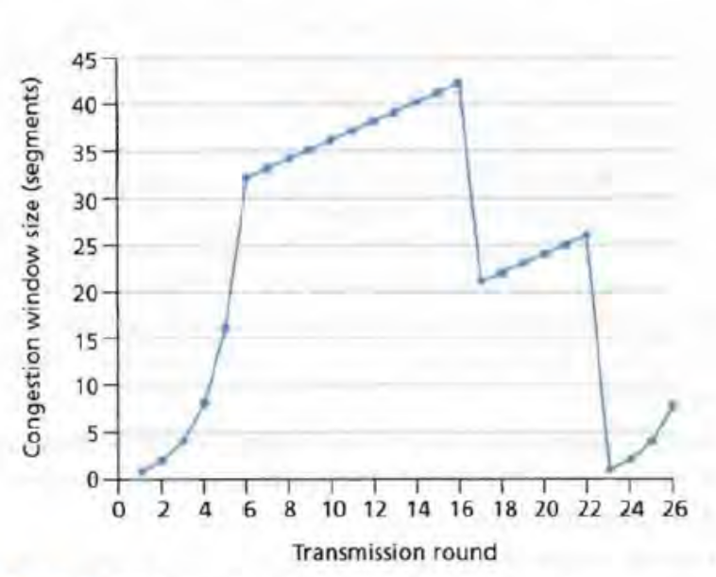
Figure 3.58 • TCP window size as a function of time

Answer:
- TCP slow start is operating in the intervals [1,6] and [23,26]
- TCP congestion avoidance is operating in the intervals [6,16] and [17,22]
- After the 16th transmission round, packet loss is recognized by a triple duplicate ACK. If there was a timeout, the congestion window size would have dropped to 1.
- After the 22nd transmission round, segment loss is detected due to timeout, and hence the congestion window size is set to 1.
- The threshold is initially 32, since it is at this window size that slow start stops and congestion avoidance begins.
- The threshold is set to half the value of the congestion window when packet loss is detected. When loss is detected during transmission round 16, the congestion windows size is 42. Hence the threshold is 21 during the 18th transmission round.
- The threshold is set to half the value of the congestion window when packet loss is detected. When loss is detected during transmission round 22, the congestion windows size is 26. Hence the threshold is 13 during the 24th transmission round.
- During the 1st transmission round, packet 1 is sent; packet 2-3 are sent in the 2nd transmission round; packets 4-7 are sent in the 3rd transmission round; packets 8-15 are sent in the 4th transmission round; packets 16-31 are sent in the 5th transmission round; packets 32-63 are sent in the 6th transmission round; packets 64 – 96 are sent in the 7th transmission round. Thus packet 70 is sent in the 7th transmission round.
- The congestion window and threshold will be set to half the current value of the congestion window (8) when the loss occurred. Thus the new values of the threshold and window will be 4.
- Threshold is 21, and congestion window size of 17th round is reset 1 then do slow start, so the congestion window size of 19th round is 4.
- round 17, 1 packet; round 18, 2 packets; round 19, 4 packets; round 20, 8 packets; round 21, 16 packets; round 22, 21 packets (not 32 packets!). So, the total number is 52.

9. Host A is sending an enormous file to Host B over a TCP connection. Over this connection there is never any packet loss and the timers never expire. Denote the transmission rate of the link connecting Host A to the Internet by R bps. Suppose that the process in Host A is capable of sending data into its TCP socket at a rate S bps, where S = 10 R. Further suppose that the TCP receive buffer is large enough to hold the entire file, and the send buffer can hold only one percent of the file. What would prevent the process in Host A from continuously passing data to its TCP socket at rate S bps? TCP flow control? TCP congestion control? Or something else? Elaborate.

Answer:
In this problem, there is no danger in overflowing the receiver since the receiver’s receive buffer can hold the entire file. Also, because there is no loss and acknowledgements are returned before timers expire, TCP congestion control does not throttle the sender. However, the process in host A will not continuously pass data to the socket because the send buffer will quickly fill up. Once the send buffer becomes full, the process will pass data at an average rate or R << S.

